HUB - WMS SHIP CONTROL -2359
- WMS system capability to freeze PGI activity from 2359hrs to 0600hrs.
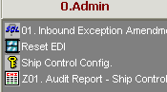

- [0.Admin] - Ship Control Configuration
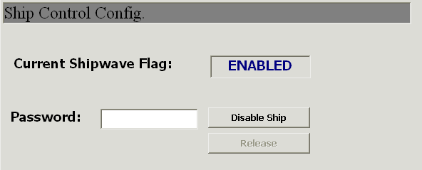

Steps:
  - Enter password. =ibm3n4 (hardcoded password)
  - Click button [Disable Ship] – to disable SHIP function
Click button [Release’ – to enable SHIP function

- [0.Admin] - Z01. Audit Report – Ship control
Description: Audit report for SHIP function control changes.
Parameter: Date range of the audit function changed.

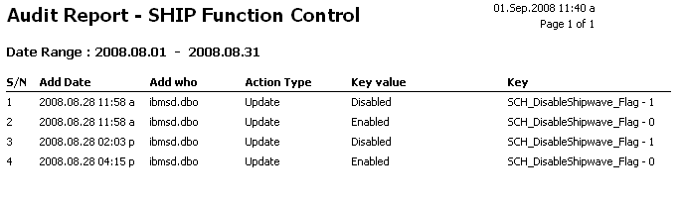

Outbound Process – message will pop out, to BLOCK SHIP function

